**MyFitnessPal Bugs**

1. **Title**: Uploading Profile photo using take a picture isn’t working

**Steps**:

1. Login to MyFitnessPall app
2. Go to profile by clicking on the photo frame in the upper left
3. Click on settings icon on the top right
4. Click on edit profile
5. Click on profile photo
6. Choose “take photo” accept permission
7. Take a photo with the back camera and click on the check icon

**Expected Result:**

Photo is updated successfully

**Actual Result:**

Photo isn’t updated

**Attachments**: N/A

**Affected devices**: Realme XT - Android 11

**Network**: 4G

**Severity**: High

**Priority**: High

**Impact**: High

1. **Ttitle**: “Mismatch password” alert msg appear although passwords are matched

**Steps**:

1. Login to MyFitnessPall app
2. Go to profile by clicking on the photo frame in the upper left
3. Click on settings icon on the top right
4. Click on change password
5. Click on show password “eye icon” for “ new password” and “retype new password”
6. Enter a short password, eg ”mnbv” in “new password” and “retype new password”

**Expected Result:**

“Password must contain at least 10 characters” error msg appear

**Actual Result:**

“Your passwords don’t match” error msg appear below “retype new password”

**Attachments**:

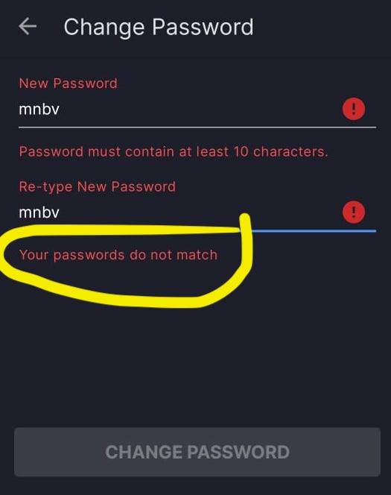

**Affected devices**: Realme XT - Android 11

**Network**: 4G

**Severity**: low

**Priority**: medium

**Impact**: low

1. **Title**: User can submit invalid email format while using forget password

**Steps**:

1. Open MyFitnessPall app (sign out if already signed in)

2. Click on “sign in” button

3. Click on “forget password” button

4. Type “m@m”

5. Click on”submit” button

**Expected Result:**

Error msg appear that mail format is wrong

**Actual Result:**

“Your passwords don’t match” error msg appear below “re-type new password”

**Attachments**:

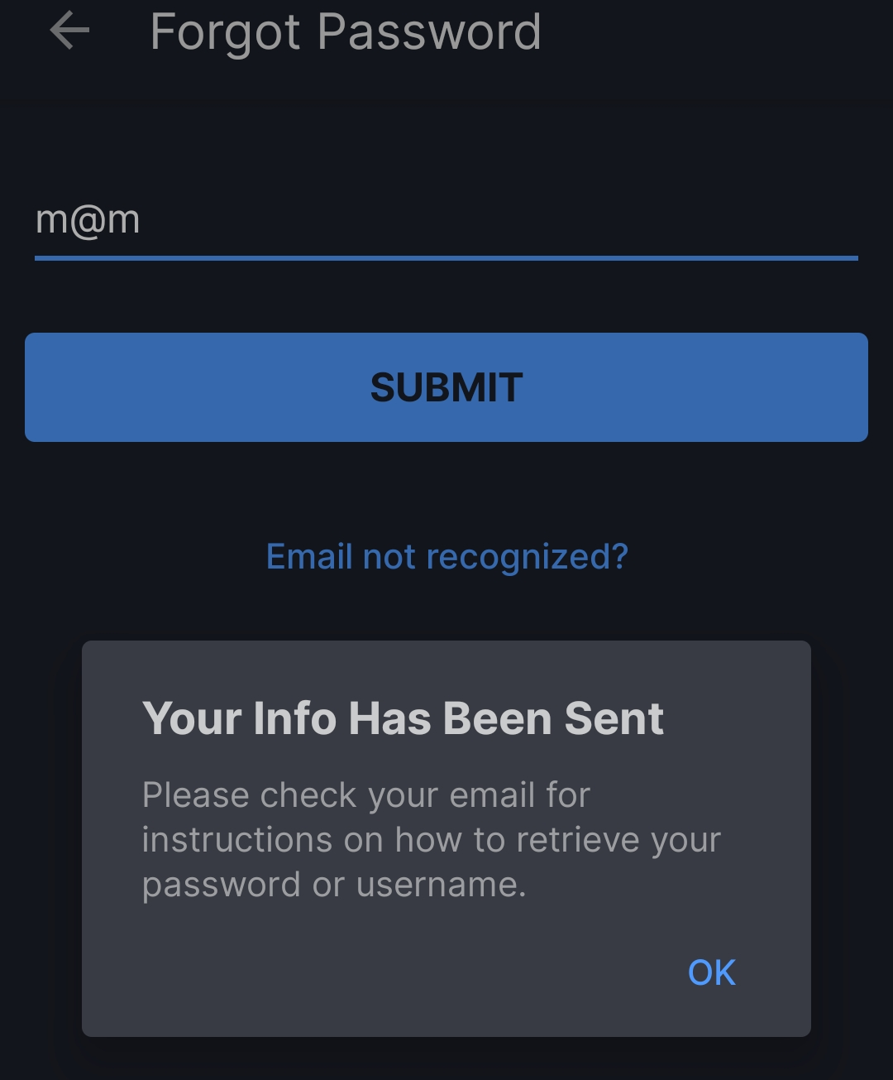

**Affected devices**: Realme XT - Android 11

**Network**: 4G

**Severity**: low

**Priority**: low

**Impact**: low

1. **Title:** “Done” button is dimmed although the text box is filled while creating a new meal

**Steps**:

1. Login to MyFitnessPall app in free trial mode

2. Click on diary tab in the bottom bar

3. Click to add food below breakfast

4. Go to my meals and click on create a meal

5. Click on the description field in the bottom

6. Check “done” button in the top right, enter text and check “done” button again

**Expected Result:**

“Done” button is dimmed only while textbox is empty

**Actual Result:**

“Done” button is dimmed while textbox is empty or have text

**Attachments**:

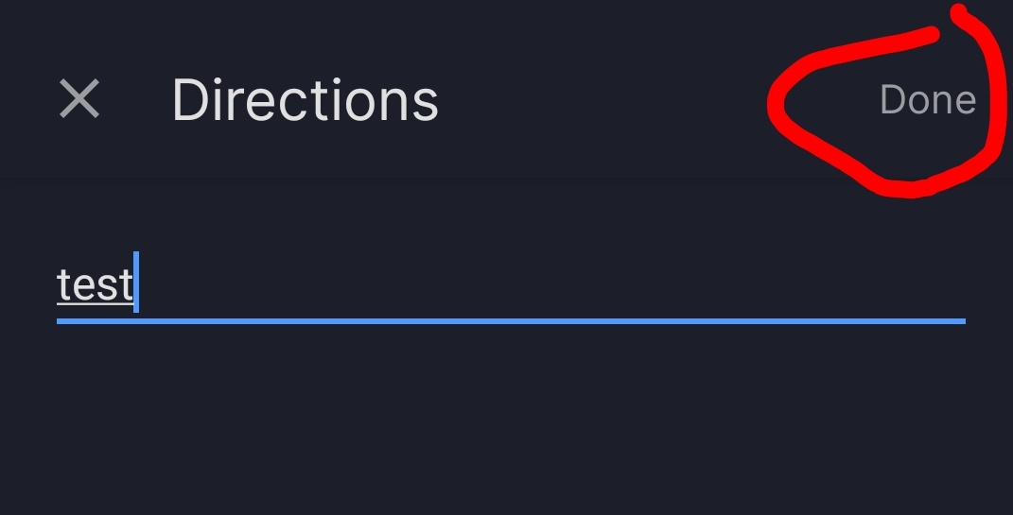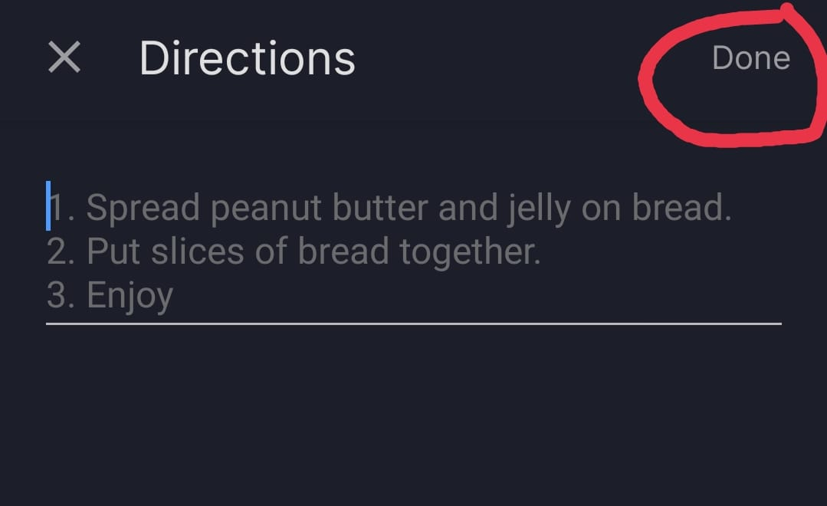

**Affected devices**: Realme XT - Android 11

**Network**: 4G

**Severity**: very low

**Priority**: very low

**Impact**: very low

1. **Title**: User can’t reply to a message in the messaging tab

**Steps**:

1. Login to MyFitnessPall app in free trial mode

2. Click on diary tab in the bottom bar

3. Click to add food below breakfast

4. Go to my meals and click on create a meal

5. Enter a “meal name”, photo and description

6. Click on ‘+’ icon to add it

**Expected Result:**

Error msg appear that mail format is wrong

**Actual Result:**

“Your passwords don’t match” error msg appear below “re-type new password”

**Attachments**:

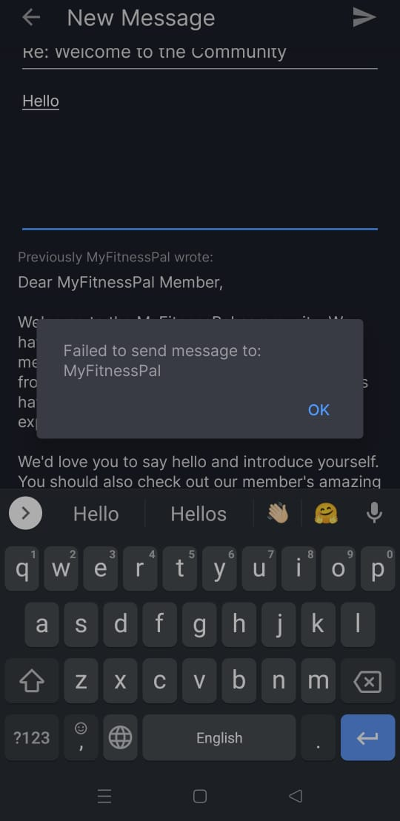

**Affected devices**: Realme XT - Android 11

**Network**: 4G

**Severity**: High

**Priority**: Hig

**Impact**: High

1. **Title**: Error appears when a user tries to post status with a picture

**Steps**:

1. Login to MyFitnessPall app
2. Go to newsfeed in the bottom bar
3. Click on “share something”
4. Click on add photo button
5. Choose “take photo” and accept permission
6. Use the back camera and then click on the check sign
7. Click on check sign to post the status

**Expected Result:**

Status is posted successfully

**Actual Result:**

Error appears and status isn’t posted

**Attachments:**

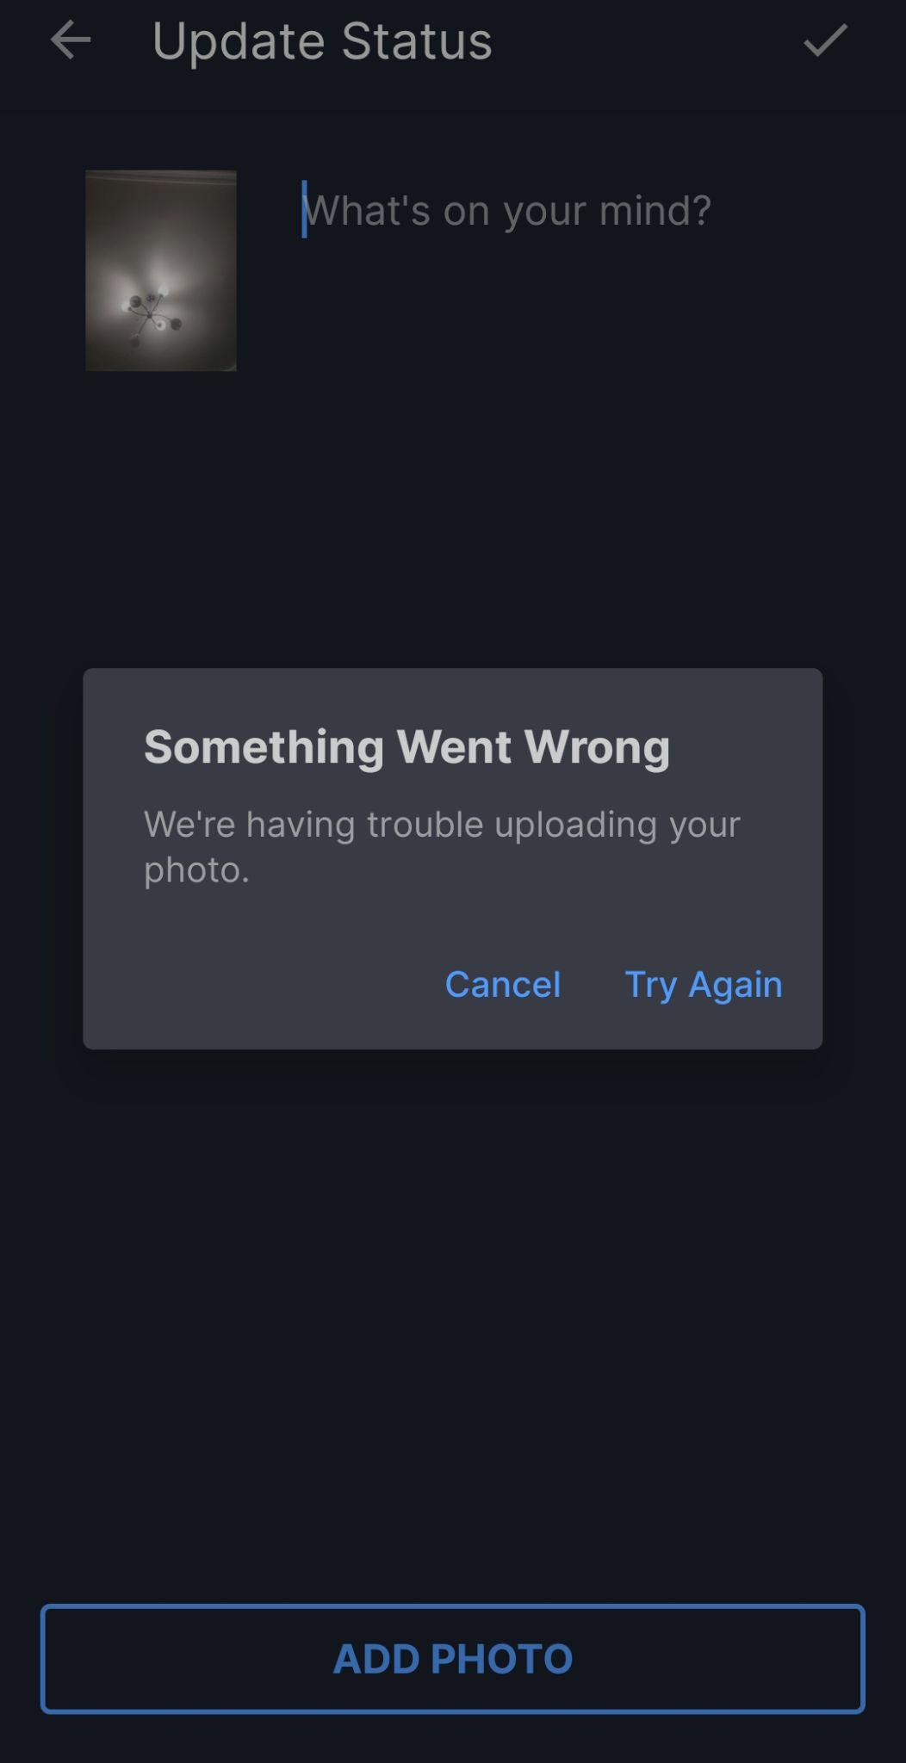

**Affected devices**: Realme XT - Android 11

**Network**: 4G

**Severity**: High

**Priority**: High

**Impact**: High